BUSINESS INSIGHT REPORT
Northwind Traders – Interactive Sales Dashboard Analysis
Prepared using Microsoft Power BI
Name: L Nithish Kumar
Register / Roll No. : 5272510213
Course: B.Com Fintech with Ai

2. Introduction

Northwind Traders dataset
Northwind Traders is a fictional international wholesale food distributor that is widely used as a teaching dataset. The Power BI file used in this report (DATASET_3.pbix) loads seven CSV tables – categories, customers, employees, order_details, orders, products and shippers – and links them with six many-to-one relationships. Together they describe 809 shipped orders placed by 91 customers in 21 countries between July 2013 and early May 2015, covering 77 products in 8 product categories and handled by 8 sales employees.
Two preparation steps were applied in Power Query: the Orders table was filtered to keep only orders that have a shipped date, and the Employees table was filtered to keep only employees who report to a manager. Six DAX measures were then created: Total Orders, Total Quantity Sold, Total Freight, Average Freight, Number of Customers and Total Sales (unit price × quantity × (1 – discount)).

Purpose of the dashboard
The “Northwind Interactive Sales Dashboard” gives a manager a one-page view of order activity, freight cost, customer coverage, product-category sales and employee workload. Year, Region and Category slicers let the viewer narrow every visual to the part of the business they want to examine.

Purpose of the Business Insight Report
This report interprets what the dashboard shows. It explains each KPI, compares product categories, months, regions and employees, separates observations (what the data shows) from insights (what it means for the business), and closes with practical recommendations.

3. Dashboard Overview
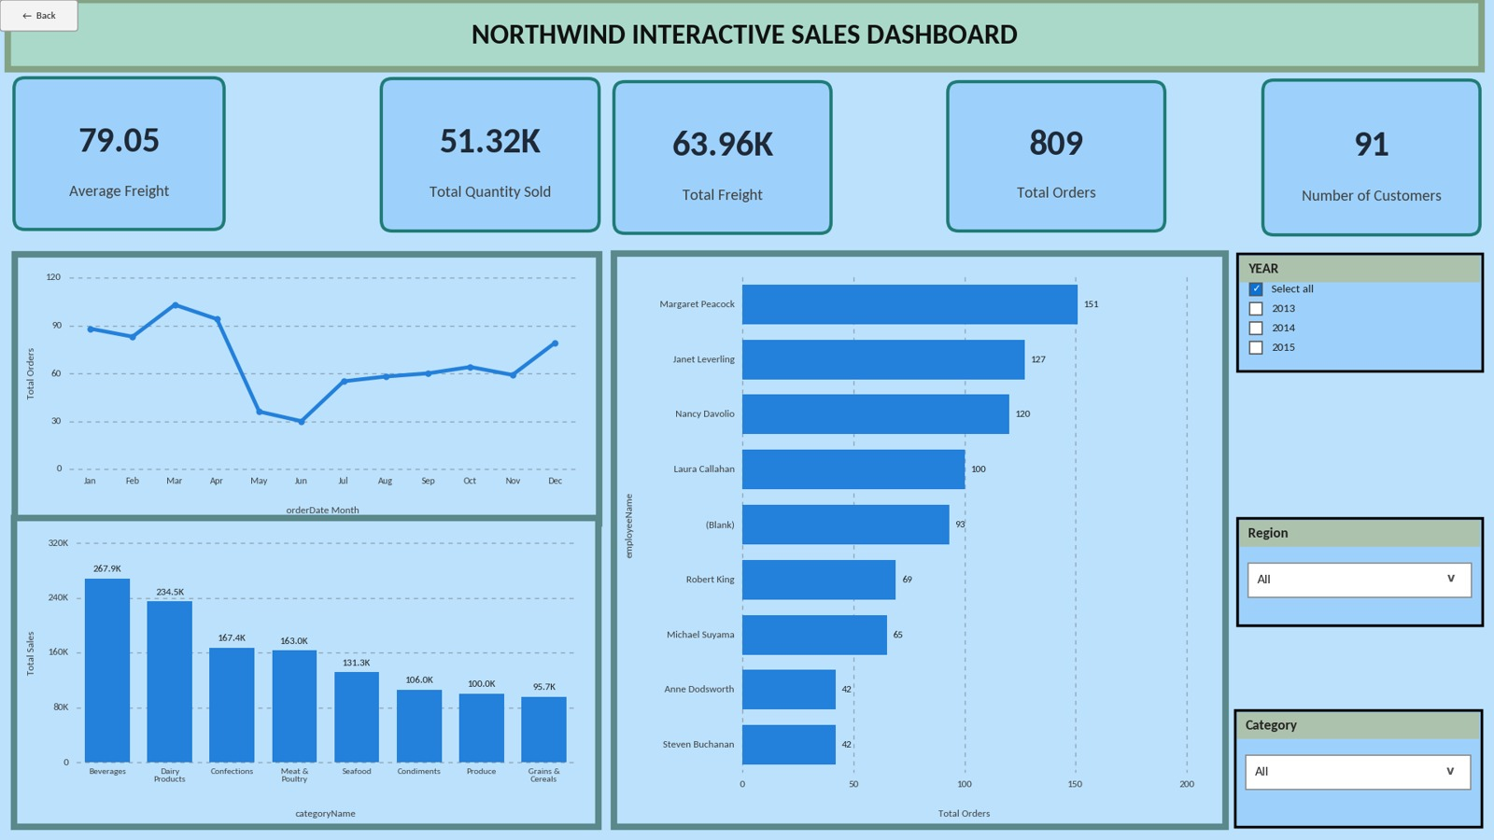
Figure 1: Northwind Interactive Sales Dashboard (no filters applied)

Purpose of the dashboard
To let a user monitor overall trading performance and drill into it by year, region and product category without building new reports.

Key components
- KPI cards – Average Freight, Total Quantity Sold, Total Freight, Total Orders and Number of Customers, placed along the top of the page.
- Orders by Month – a line chart of Total Orders by calendar month (top left).
- Sales by Product Category – a column chart of Total Sales for each of the 8 categories, sorted from highest to lowest (bottom left).
- Orders by Employee – a horizontal bar chart of Total Orders handled by each employee (centre).
- Category Tooltip – hovering over a category column opens a small tooltip page showing Total Orders, Total Quantity Sold and Total Sales for that category (Figure 2).
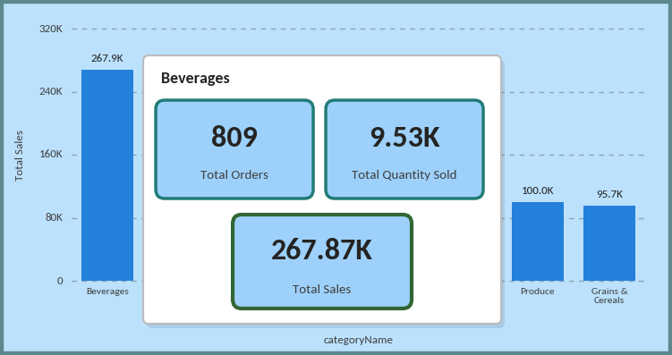
Figure 2: Category tooltip shown when hovering over the Beverages column

Interactive filters available
- Year – a slicer with the values 2013, 2014 and 2015 (taken from Order Date).
- Region – a dropdown slicer built on the customer’s country (21 countries).
- Category – a dropdown slicer with the 8 product categories.
Filter behaviour to keep in mind: because of the way the tables are related, the Category slicer changes Total Quantity Sold and Total Sales but not Total Orders, Freight, Number of Customers or the Orders by Employee chart. The Year slicer does not change Number of Customers, which always counts the customers in the selected region.

4. KPI Analysis

Total Orders
The dashboard records 809 shipped orders. With 91 customers this is roughly 8.9 orders per customer, which points to a business built on repeat buying rather than one-off purchases. Order activity is not spread evenly across time: 2014 is the only complete year (408 orders, about 34 a month), while 2015 already has 249 orders in its first four months.

Total Quantity Sold
A total of 51,317 units were sold, or about 63 units per order. This is a wholesale pattern – customers buy in bulk. Note that this figure includes 1,198 units on order lines whose orders are not in the shipped-orders table; once a Year or Region filter is applied those lines drop out, so the three yearly totals (9,581 + 25,489 + 15,049 = 50,119) add up to slightly less.

Total Freight
Freight cost amounts to 63.96K, which is about 5% of the 1.27M in total sales and equals roughly 1.25 per unit shipped. Freight moves closely with order volume, but not perfectly: the USA generated 13.73K of freight from 119 orders while Germany generated 11.12K from 120 orders, so where an order is shipped matters as much as how many orders there are.

Average Freight
The average freight per order is 79.05. This average is pulled upwards by a few very large shipments – the median order pays only 41.90 and the most expensive order cost 1,007.64 – so the typical order is far cheaper than the average suggests. By country, Austria has the highest average (185.62) and Poland the lowest (25.11).

No. of Customers
The card shows 91 customers, the full customer list. In practice 89 of them have at least one shipped order. Customer coverage is broad (21 countries) but volume is concentrated: Germany, the USA and Brazil together place 39.6% of all orders, and the top five countries (adding France and the UK) place 55.7%.
Suggested format
KPI | Value | Interpretation
Total Orders | 809 | Healthy order activity; about 8.9 orders per customer shows repeat buying. 2014 was the only full year (408 orders).
Total Quantity Sold | 51,317 | Bulk-sized orders averaging about 63 units. Includes 1,198 units on lines with no shipped order.
Total Freight | 63,955 (63.96K) | About 5% of total sales; grows with order volume but varies strongly by destination.
Average Freight | 79.05 | Skewed by a few very large shipments (median 41.90, maximum 1,007.64).
No. of Customers | 91 | Broad coverage across 21 countries, but 39.6% of orders come from just three countries.

5. Product Category Performance Analysis
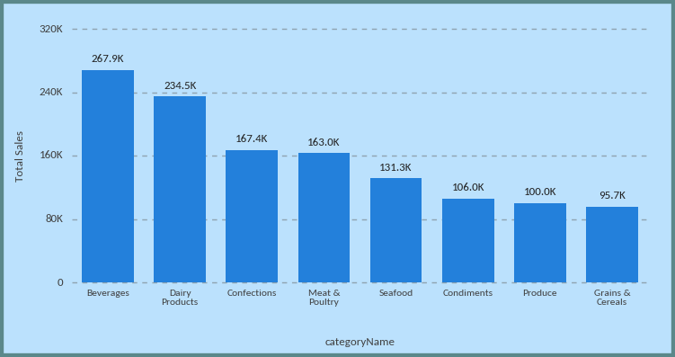
Figure 3: Sales by Product Category
Total Sales for the eight categories, ranked from highest to lowest, together with the volume sold and the average sales value per unit:
Category | Total Sales | Share | Units sold | Sales per unit
Beverages | 267,868 | 21.2% | 9,532 | 28.10
Dairy Products | 234,507 | 18.5% | 9,149 | 25.63
Confections | 167,357 | 13.2% | 7,906 | 21.17
Meat & Poultry | 163,022 | 12.9% | 4,199 | 38.82
Seafood | 131,262 | 10.4% | 7,681 | 17.09
Condiments | 106,047 | 8.4% | 5,298 | 20.02
Produce | 99,985 | 7.9% | 2,990 | 33.44
Grains & Cereals | 95,745 | 7.6% | 4,562 | 20.99

- Highest-selling category: Beverages, with 267.9K in sales (21.2% of the total) and the most units sold (9,532).
- Lowest-selling category: Grains & Cereals, with 95.7K (7.6%).
- Relative differences: Beverages sells about 2.8 times as much as Grains & Cereals. Beverages and Dairy Products together account for 39.7% of sales, and the top three categories (adding Confections) for 52.9%. The bottom five categories are all within a narrow 95K–163K band.
- Important observations: sales rank does not follow unit rank. Meat & Poultry ranks fourth in sales but sells only 4,199 units because its sales value per unit (38.82) is the highest. Produce is similar (33.44 per unit) but has the fewest units. Seafood is the opposite: 7,681 units, but at 17.09 per unit it ranks only fifth.

Key Insight
Sales are led by two volume-driven categories – Beverages and Dairy Products – while Meat & Poultry and Produce earn well above average value per unit. Volume categories should be protected for availability, and high-value categories are the best candidates for margin-focused growth.

6. Monthly Order Trend Analysis
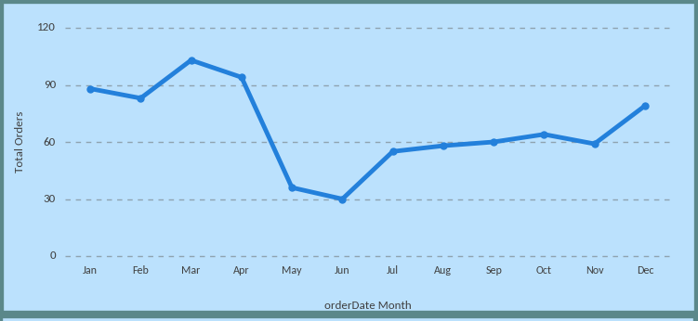
Figure 4: Orders by Month (all years combined)
- Highest-order month: March, with 103 orders.
- Lowest-order month: June, with 30 orders.
- Overall pattern: orders are high in the first four months (88, 83, 103 and 94), fall sharply in May (36) and June (30), recover gradually from July to November (55–64) and rise again in December (79).
- Major fluctuations: the largest swing is the drop of 58 orders from April to May, followed by a gain of 25 orders from July to June-end and a further 20-order jump into December.
How to read this chart. The data runs from July 2013 to early May 2015, so months are not covered equally: May and June come only from 2014 (plus 4 orders in early May 2015), January–April come from 2014 and 2015, and July–December come from 2013 and 2014. The May–June “dip” is therefore mainly a data-coverage effect rather than a genuine collapse. Selecting 2014 – the only full year – gives a flatter picture: 29 to 38 orders a month from January to November and a clear peak of 48 in December.
Year | Orders | Avg freight | Months covered
2013 | 152 | 67.63 | July – December
2014 | 408 | 79.58 | January – December
2015 | 249 | 85.17 | January – early May

Key Insight
Once coverage is taken into account, order activity is growing strongly and is seasonal only at year-end. January–April 2015 produced 245 orders against 123 in the same months of 2014 – about double – and December is consistently the busiest month of the second half of the year.

7. Regional / Filter-Based Analysis
The dashboard has a Region slicer instead of a separate regional chart. The three regions with the most orders – Germany, the USA and Brazil – were selected in turn to show how every visual responds.

KPI changes
Region | Orders | Qty sold | Freight | Avg freight | Custs. | Total sales
All regions | 809 | 51,317 | 63.96K | 79.05 | 91 | 1.27M
Germany | 120 | 9,075 | 11.12K | 92.63 | 11 | 227.8K
USA | 119 | 9,223 | 13.73K | 115.38 | 13 | 243.6K
Brazil | 81 | 4,098 | 4.71K | 58.18 | 9 | 103.1K

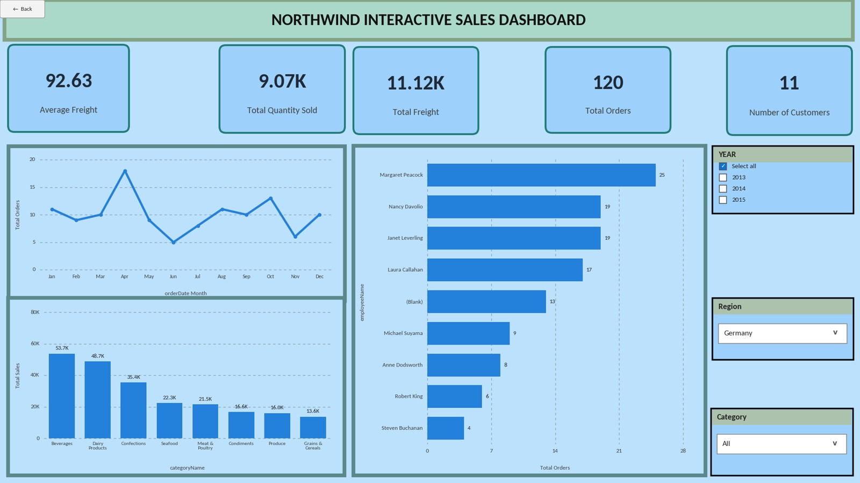
Figure 5: Dashboard with Region = Germany
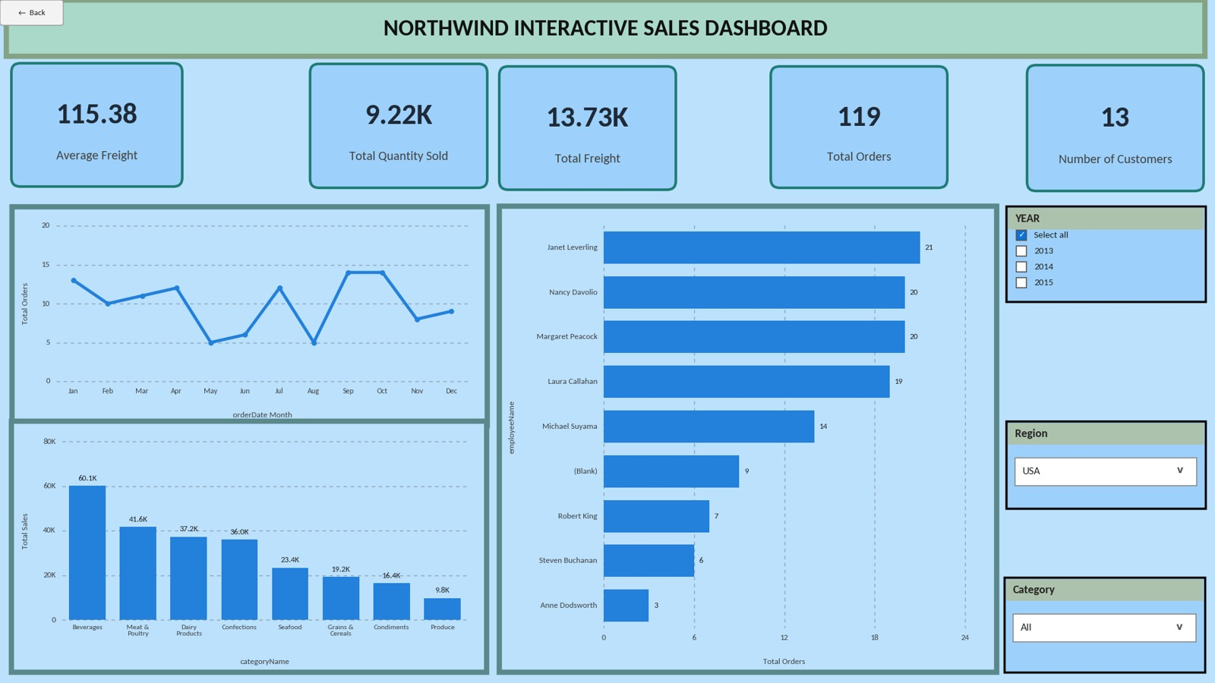
Figure 6: Dashboard with Region = USA
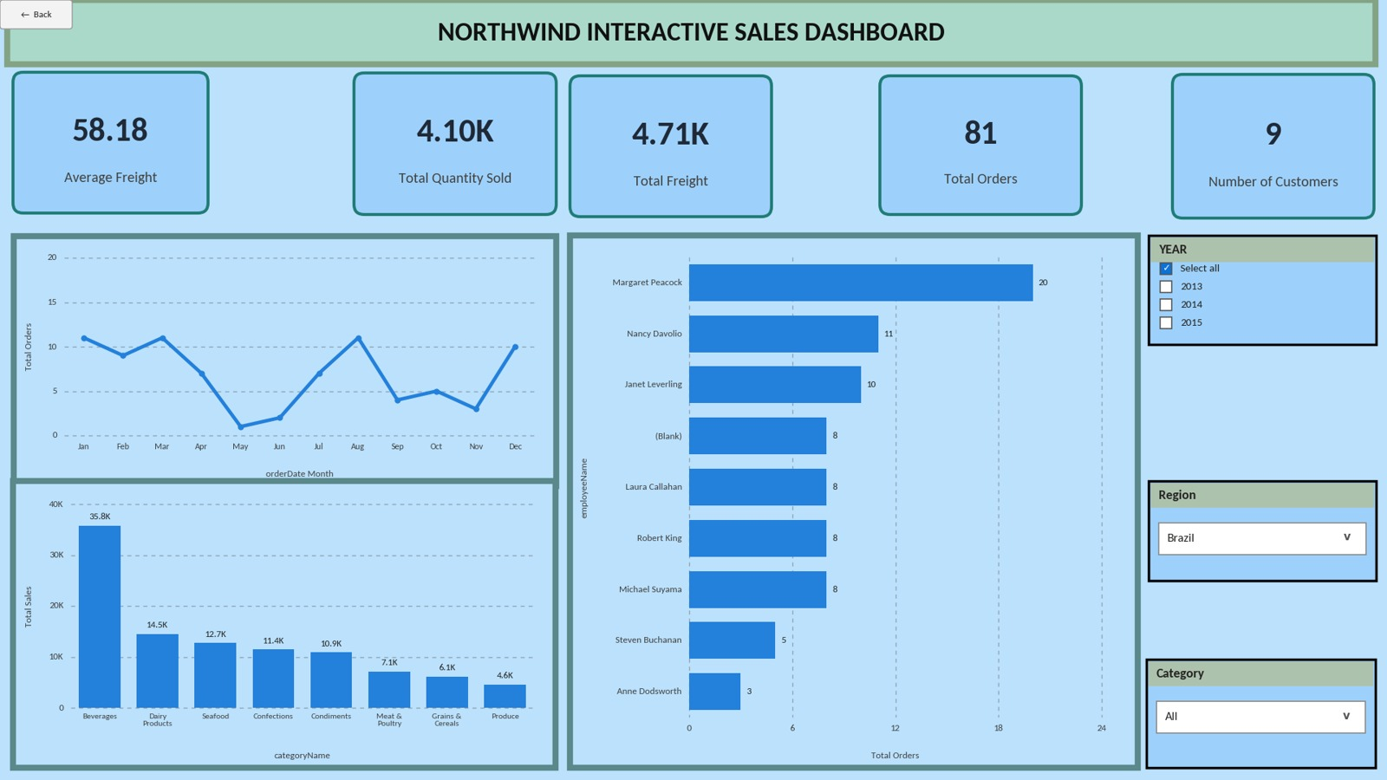
Figure 7: Dashboard with Region = Brazil

Category, monthly and employee changes
- Category changes: Beverages is the top category in all three regions but its dominance varies – 34.7% of Brazil’s sales, 24.7% of the USA’s and 23.6% of Germany’s. Meat & Poultry is the USA’s second-best category (41.6K) but is not in Germany’s top three, where Dairy Products (48.7K) comes second.
- Monthly order changes: the national dip in May–June is confirmed in every region. Germany peaks in April (18 orders), the USA in September and October (14 each), and Brazil in January, March and August (11 each) with almost no orders in May (1).
- Employee performance changes: Margaret Peacock leads Germany (25 orders) and Brazil (20), but in the USA the top three are almost level – Janet Leverling 21, Nancy Davolio 20, Margaret Peacock 20.
Suggested format
Region | Major Observation | Business Insight
Germany | Highest order count (120) from only 11 customers; Beverages 53.7K and Dairy Products 48.7K lead; Grains & Cereals is lowest (13.6K); average freight 92.63. | Germany is the most active market and relies on a small group of very frequent buyers. Losing one account would be noticeable, so account retention matters most here.
USA | Largest sales (243.6K) and total freight (13.73K); highest average freight of the three (115.38); Beverages 60.1K then Meat & Poultry 41.6K; Produce lowest (9.8K). | The USA is the most valuable market but also the most expensive to ship to. It is the best place to review freight terms and to promote Meat & Poultry.
Brazil | 81 orders and 4.10K units; lowest average freight (58.18); Beverages alone is 34.7% of sales; almost no orders in May (1) or June (2). | Brazil is a mid-sized market that depends heavily on one category and is highly seasonal. Cross-selling Dairy Products and Seafood would reduce this dependence.

8. Employee Performance Analysis
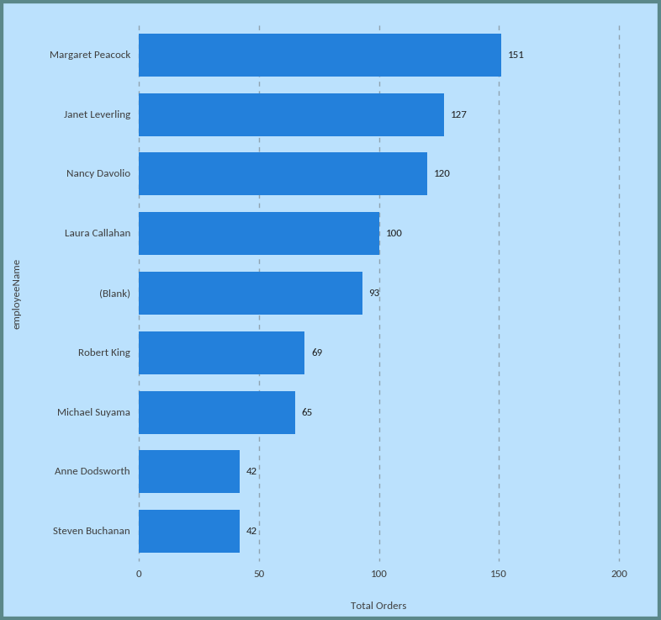
Figure 8: Orders by Employee
- Highest-performing employee: Margaret Peacock with 151 orders (18.7% of all orders).
- Lowest-performing employee: Anne Dodsworth and Steven Buchanan, tied at 42 orders each.
- Difference between employees: the top employee handles about 3.6 times as many orders as the lowest. Margaret Peacock, Janet Leverling (127) and Nancy Davolio (120) together handle 398 orders, 49% of the total. Laura Callahan follows with 100, then Robert King (69) and Michael Suyama (65).
- Changes after applying filters: the ranking is fairly stable for the year filter – in 2014 Margaret Peacock (81) still leads Janet Leverling (71) – but changes by region: in the USA Janet Leverling leads with 21 orders, ahead of Nancy Davolio and Margaret Peacock (20 each), while in Germany Margaret Peacock leads clearly with 25.
Data note: the chart contains a “(Blank)” bar of 93 orders. These belong to employee ID 2, who was removed from the Employees table by the Power Query filter (employees with no manager). The orders are still counted in Total Orders but cannot be matched to a name, so the ranking above understates that employee’s contribution.
Key Insight
Order handling is uneven: three sales representatives handle about half of all orders, while the two lowest employees include a sales manager (Steven Buchanan) whose role is not purely order-taking. Workload, not only skill, is likely behind the gap, and the ranking changes by region.

9. Business Insights
Each insight below links an observation (what the data shows) to what it means for the business.

Insight 1 – Growth is real, and the monthly chart alone hides it
Observation: January–April 2015 recorded 245 orders versus 123 in January–April 2014, and average freight rose each year (67.63 → 79.58 → 85.17). Insight: demand is roughly doubling, so planning should be based on year-specific trends, not on the combined monthly chart, whose low May–June values only reflect incomplete data coverage.

Insight 2 – Sales depend on a few categories and a few markets
Observation: Beverages and Dairy Products make up 39.7% of sales, and Germany, the USA and Brazil place 39.6% of orders. Insight: the business is exposed to shortages in two categories and to demand changes in three markets. Brazil is the most exposed, with 34.7% of its sales from Beverages alone.

Insight 3 – Freight is a controllable cost that varies by destination
Observation: freight is about 5% of sales, but average freight per order ranges from 25.11 (Poland) to 185.62 (Austria), and Austria generated 7.05K of freight from just 38 orders. Insight: shipping cost is driven by destination and order size rather than volume alone, so it can be reduced through carrier choice, order consolidation and minimum order values.

10. Business Recommendations
Area | Recommendation
Product category planning | Protect Beverages and Dairy Products as volume anchors, and grow Meat & Poultry and Produce, which earn the highest sales value per unit (38.82 and 33.44). Review pricing or bundling for Seafood, which sells many units at the lowest value per unit (17.09).
Inventory planning | Stock to year-specific demand: raise stock levels ahead of the December peak and the January–April surge seen in 2015, and set safety stock for Beverages and Dairy Products first because they generate 39.7% of sales.
Regional strategy | Retain the Germany and USA accounts with dedicated account management. In Brazil, reduce reliance on Beverages by cross-selling Dairy Products and Seafood, and plan promotions for the weak May–June period.
Employee performance | Rebalance order allocation so the top three representatives do not carry about half the volume. Use Margaret Peacock’s approach as a coaching model, and fix the Employees table so that the 93 “(Blank)” orders are attributed correctly.
Monthly order planning | Base staffing and promotions on the Year-filtered chart. Use 2014 as the reference year for seasonality and update the plan when full-year 2015 data is available.
Freight management | Renegotiate carrier terms or set minimum order values for high-freight destinations (Austria, Ireland, the USA), and consolidate shipments to reduce the impact of the few very large freight charges.
Customer targeting | Focus retention on the customers in Germany, the USA, Brazil, France and the UK (55.7% of orders), and run targeted campaigns to activate the 2 customers with no shipped orders and to grow small markets such as Poland and Norway.

11. Conclusion
- Overall dashboard findings: 809 shipped orders, 51,317 units, 63.96K in freight and 91 customers, with sales of 1.27M led by Beverages and Dairy Products, orders that doubled year-on-year in early 2015, and Germany and the USA as the two most active markets.
- Most important business insight: demand is growing quickly but is concentrated in a few categories, markets and employees, so the business is exposed if any of these weakens.
- Key recommendation: plan inventory and staffing on year-specific demand, protect the two volume categories, and diversify Brazil and other single-category markets while managing freight cost by destination.
- How Power BI helped: the data model, DAX measures and slicers made it possible to move from the total picture to a single region, year or category in one click, to compare categories, months and employees on one page, and to spot data issues such as the “(Blank)” employee and uneven month coverage.

